Mathematical Analysis of Recursive Algorithms
EXAMPLE 1 Compute the factorial function F(n) = n! for an arbitrary nonnegative integer n. Since
n!= 1 . . . . . (n − 1) . n = (n − 1)! . n for n ≥ 1
and 0!= 1 by definition, we can compute F(n) = F(n − 1) . n with the following recursive algorithm.
ALGORITHM F(n)
//Computes n! recursively
//Input: A nonnegative integer n
//Output: The value of n!
if n = 0 return 1
else return F(n − 1) * n
Basic Operation: Multiplication
the number of multiplications M(n) needed to compute it must satisfy the equality
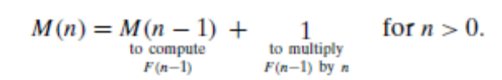
Recurrence Relation M(n) = M(n − 1) + 1,
Initial Condition M(0) = 0.

M(n) = M(n − 1) + 1 substitute M(n − 1) = M(n − 2) + 1
= [M(n − 2) + 1]+ 1= M(n − 2) + 2 substitute M(n − 2) = M(n − 3) + 1
= [M(n − 3) + 1]+ 2 = M(n − 3) + 3.
….
M(n) = M(n − i) + i.
Substitute i=n
M(n) =M(n − n) + n = n.

General Plan for Analyzing the Time Efficiency of Recursive Algorithms
1. Decide on a parameter (or parameters) indicating an input’s size.
2. Identify the algorithm’s basic operation.
3. Check whether the number of times the basic operation is executed can vary on different inputs of the same size; if it can, the worst-case, average-case, and best-case efficiencies must be investigated separately.
4. Set up a recurrence relation, with an appropriate initial condition, for the number of times the basic operation is executed.
5. Solve the recurrence or, at least, ascertain the order of growth of its solution.

EXAMPLE 2 Tower of Hanoi puzzle
Basic Operation: Disk move
Recurrence Relation:M(n) = M(n − 1) + 1+ M(n − 1) for n > 1.
Recurrence Relation and Initial condition
M(n) = 2M(n − 1) + 1 for n > 1,
M(1) = 1.
M(n) = 2M(n − 1) + 1 sub. M(n − 1) = 2M(n − 2) + 1
= 2[2M(n − 2) + 1]+ 1= 2²M(n − 2) + 2 + 1 sub. M(n − 2) = 2M(n − 3) + 1
= 2²[2M(n − 3) + 1]+ 2 + 1= 2³M(n − 3) + 2² + 2 + 1.
generally, after i substitutions, we get
M(n) = 2^{i}M(n − i) + 2^{i−1} + 2^{i−2} + . . . + 2 + 1= 2^{i}M(n − i) + 2^{i} − 1.
Since the initial condition is specified for n = 1, which is achieved for i = n − 1, we get the following formula for the solution to recurrence (2.3):
M(n) = 2^{n−1}M(n − (n − 1)) + 2^{n−1} − 1
= 2^{n−1}M(1) + 2^{n−1} − 1= 2^{n−1} + 2^{n−1} − 1= 2^{n} − 1.
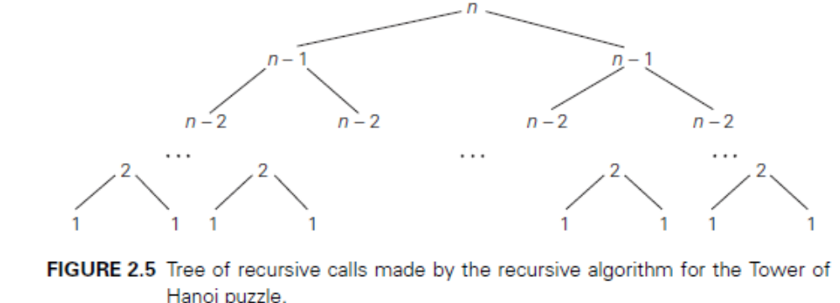
By counting the number of nodes in the tree, we can get the total number of calls made by the Tower of hanoi algorithm:
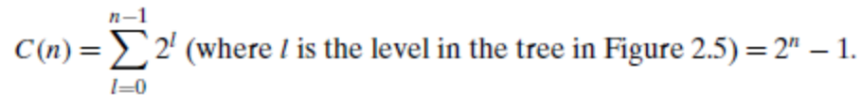

EXAMPLE 3
ALGORITHM BinRec(n)
//Input: A positive decimal integer n
//Output: The number of binary digits in n’s binary representation
if n = 1 return 1
else return 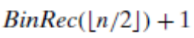
Basic Operation: Addition
Recurrence Relation and Initial condition
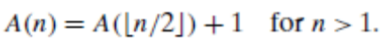
A(1) = 0.
By smoothness rule,

A(2^{k}) = A(2^{k−1}) + 1 for k > 0,
A(2⁰) = 0.

A(2^{k}) = A(2^{k−1}) + 1 substitute A(2^{k−1}) = A(2^{k−2}) + 1
= [A(2^{k−2}) + 1]+ 1= A(2^{k−2}) + 2 substitute A(2^{k−2}) = A(2^{k−3}) + 1
= [A(2^{k−3}) + 1]+ 2 = A(2^{k−3}) + 3 . . .
. . .
= A(2^{k−i}) + i
. . .
= A(2^{k−k}) + k.
Thus,
A(2^{k}) = A(1) + k
A(2^{k}) = 0 + k
A(2^{k}) = k ----------------- (1)

Taking log on both side, n=2^{k}
log₂n= log ₂2^{k}
log₂n =k log ₂2
log₂n=k
k=log₂n

Sub k= log₂n and 2^{k}=n in the equation (1)

